**Azure Batch**

Azure Batch is used to run large-scale parallel and HPC batch jobs efficiently,it creates and manages a pool of compute nodes (virtual machines), installs the applications you want to run, and schedules jobs to run on the nodes.

There is no cluster or job scheduler software to install,Manage, or scale.Here you use Batch API’s and tools & command-line scripts or Azure portal to configure manage and monitor your jobs.

Batch supports large-scale [rendering workloads](https://learn.microsoft.com/en-us/azure/batch/batch-rendering-service) with rendering tools including Autodesk Maya, 3ds Max, Arnold, and V-Ray.

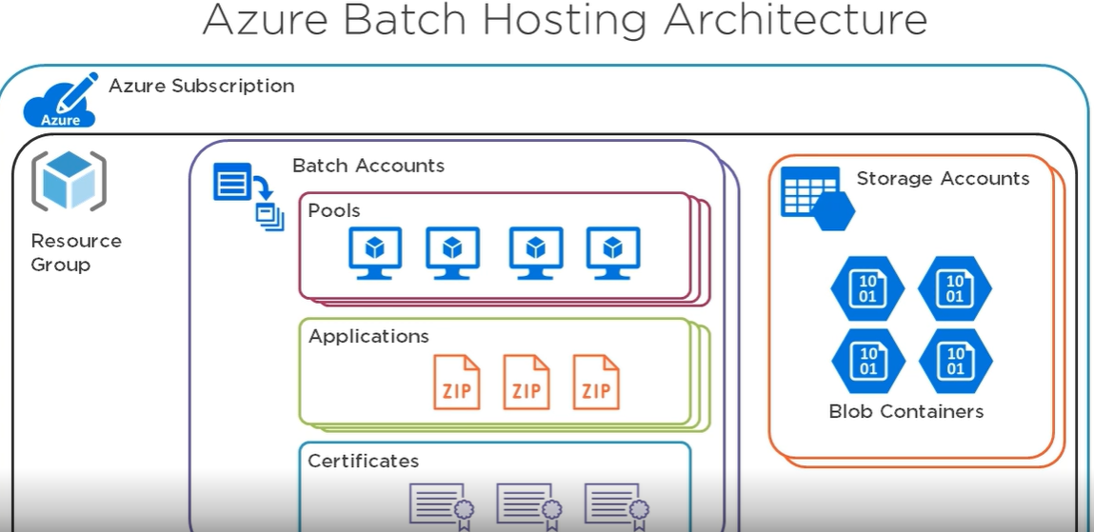

Azure Batch feature :

* Resource management
* Process Management
* Resource and process monitoring

Some examples of intrinsically parallel workloads you can bring to Batch:   
 Financial risk modeling using Monte Carlo simulations  
 VFX and 3D image rendering  
 Image analysis and processing   
 Media transcoding   
 Genetic sequence analysis  
 Optical character recognition (OCR)   
 Data ingestion, processing, and ETL operations   
 Software test execution

**Pricing**  
Here is no additional charge for using Batch. You only pay for the underlying resources consumed, such as the virtual machines, storage, and networking.

* Azure batch is free of cost to all
* Azure batch is using the VM it is chargeable 0.02 - 20 $ per hour
* Azure batch if its using worker role it is also chargeable (0.02 - 20 $ / hour)

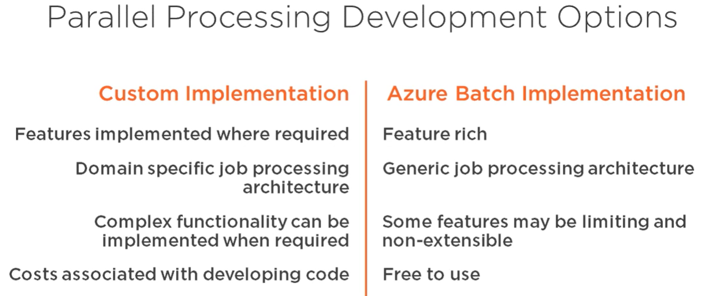

Azure batch steps:

1. Create a resource group
2. Create a new batch service account
3. In the batch account we need to create pools
4. In the pools we should add VM’s and can add jobs
5. In jobs we can create tasks to perform task

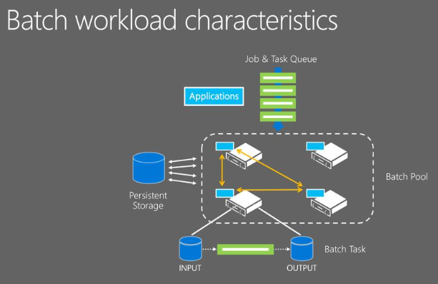

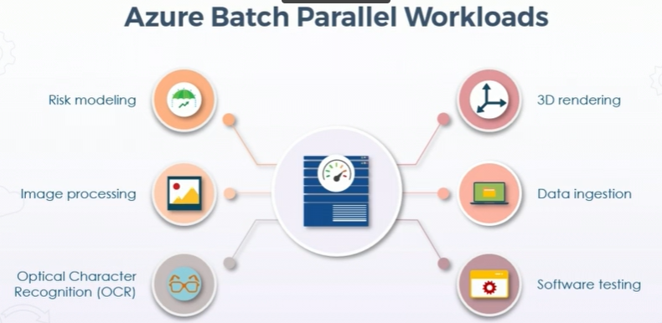

**Azure batch Capabilities**

* Large scale rendering workloads
* Do azure parallel R package

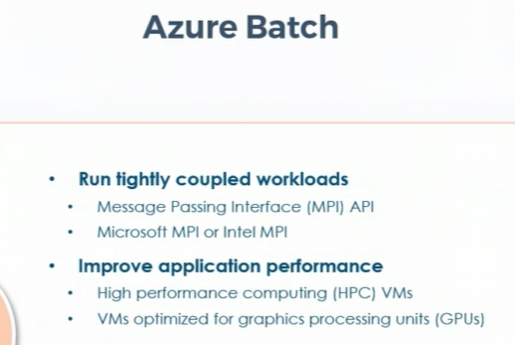

Azure Batch process

* Input files (Apps & process data like scripts to azure storage account)
* Compute nodes(we need to config the pool of like which vm are going to run the process or the app we need to add a job to run on the pool and then to add the task on to the job)
* Download to batch (AB will download the data to the app to the node which is assigned to perform each task and which will execute the task which is assigned on the node by using the application which has been provided)
* Monitor (we can monitor the stats and its runs by creating the https batch API )
* Upload the result data (we can configure the AB to upload the batch data to that of the azure storage account)
* Downloaded data for the processing (AB can be able to downlod the data to that of the application)

Which can run concurrently to run the several task on the single node

\